Background:

危害严重：Severity of fall “injuries, fear of falling, loss of independence, and death of the third individual of the elderly who suffer these accidents”

各个国家对健康开销大：The cost for the health problems is extremely expensive

Our approach is vision-based:

Reason: 摄像头足够提供丰富的信息“cameras provide very rich information about person and environment”

适用场合多，迎合未来发展方向，”Airports, train and bus stations, malls and even streets are already equipped with cameras. cameras are also installed in elderly care centers.”

Approach: 1)train model on the Imagenet dataset to acquire the relevant features

2)train CNN on UCF101 action dataset

3)calculate the optical flow images of consecutive frames

4)transfer learning by reusing the network weights and fine-tuning the classification layers.

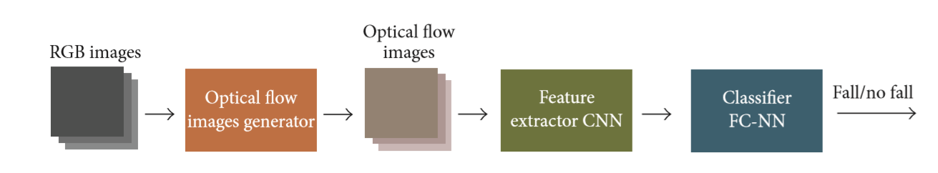

Optical flow stack order:

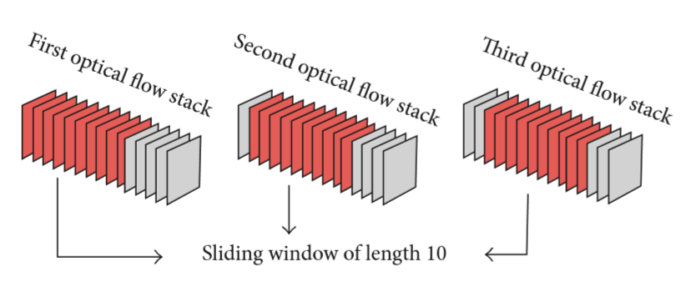

Loss function:

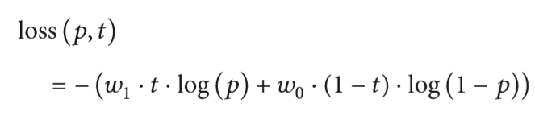

W0 and W1 are, respectively, the weights for the “fall class” and “no fall class”.

We choose w0>1.0 biases the learning towards falls (in case of w1=1) 使得miss尽量的小，但是允许一定的false alarm，因为健康的考虑。

数据集的局限性，原文

“Datasets we use are recorded in controlled environments with various restrictions:

1. There is only one actor in a video
2. Images are recorded under suitable and stable lighting conditions, avoiding dark situations or abrupt lighting changes.”

evaluation

Binary classification problem. We use sensitivity and specificity to evaluate the result because they are not biased by imbalanced class distributions, when “the number of fall samples is usually much lower than the number of nonfall samples”.

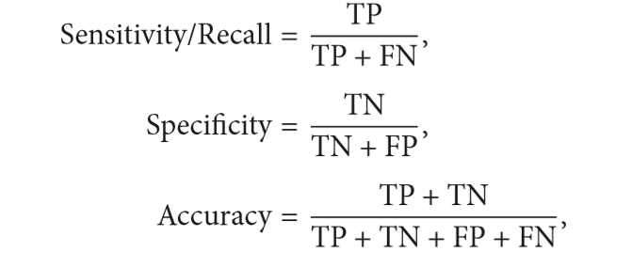

Experimental setup:

1)Search for the best configuration

2)Comparison with the state of the art

3)Test with different lighting conditions: 光线

i) images darkened

ii) dynamic light

4)generality test

Best configuration results:

“Split each dataset into training and test set with 80:20”

Learning rate: around 10^-3 and 10^-5

Minibatch size: ranging from 64 to 1,024 using powers of 2

Class weight: w0 = 2.0

Analysis of false alarms and missed detection:

False alarm: “As we are using a sliding window approach, the errors may be overlapping. We computed the amount of stacks per error source and we ordered the errors taken into account that number of stacks for each source divided by the total amount of stacks of all the sources.”

Error 分析

All the error could be classified into two groups:

“

1. Events that do not appear many times in the datasets are difficult to learn, as the network does not have enough samples.
2. Limitations of the cameras and the optical flow algorithm. Long distance between the actor and the camera, optical flow is not able to capture the movement of the person and the output result is a blank image.”

For the lighting experiments:

1. Static lighting experiments: change the lighting condition to simulate night-like scenarios光线暗的情况

结果：当人离地面很近时（接触到地面），光流难以探测到人，因为人的光线亮度与地面很接近（都很暗）

并尝试在训练的时候变将训练图像暗化sensitivity有了较为显著的提升，specificity略微降了一点点。但是作者认为事实上变化没有数据显示的那么大，因为他们并没有找到适合这一情况的模型结构。

1. Dynamic lighting experiments: add a dynamic artificial lighting.

动态的光线更加贴近生活

同样在训练的时候加入了变化的光线，sensitivity有了非常大的提升，从28.04%提升到了90.82%。作者从动态光线的实验中得出，他们的模型有接受新的环境条件的能力，当训练数据合适的情况下。。